

Open Green Map iFrame Tutorial:

How to embed a map in your own website or blog using
complete, map-only, free-style, and pop-up layouts

Open Green Map is an online mapping platform that allows Green Mapmakers to create interactive Green Maps of their communities, while inviting users to add impacts, stories, photos, and videos about the sites. Open Green Map allows users to connect sustainable and green sites in their local communities to broader green impacts and movements around the world.

Open Green Map (OGM) also allows Mapmakers to share their maps on external websites with easy-to-use widgets and HTML code. We have provided step-by-step embedding instructions so you can begin to share your map immediately.

Option 1: Complete Webpage Layout

This option is available to public users, registered users and Mapmakers.

1. Locate the HTML code for the Complete Page Layout:
http://www.opengreenmap.org/share_promote#widget
2. Or Copy it here:

<iframe WIDTH="100%" HEIGHT="680" SRC="http://www.opengreenmap.org/greenmap/nycs-green-apple-map" SCROLLING="auto" FRAMEBORDER="0" border="0"></iframe>

To create an iframe widget with another map, copy and paste the map URL into the code, replacing the example URL (in bold).

For this example we used the NYC Green Apple Map, and copied the URL from the top of the website:

The final product can be placed on a white page or can appear with your website's design around it:

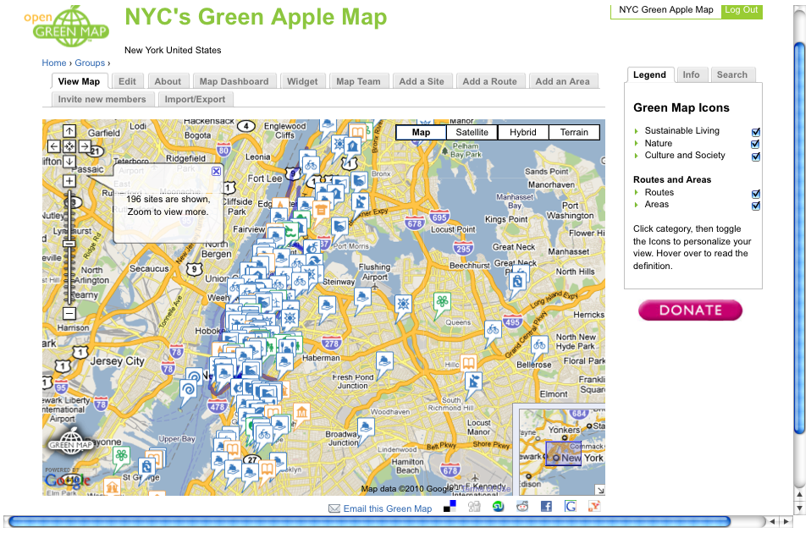

Note the scrolling bars on the lower and right sides of the page. The iframe widget is displayed within those constraints, which can be changed by editing the “WIDTH” and “HEIGHT” parameters within the HTML code. This changes the size of the window, which is up to you to define.

Important: if you cannot see the Google and Green Map logos when you scroll down, increase the height.

The example provided uses the Swansea Green Map as a source website:

<iframe WIDTH="100%" HEIGHT="680" SRC="http://www.opengreenmap.org/en/greenmap/swansea-green-map" SCROLLING="auto" FRAMEBORDER="0" border="0"></iframe>

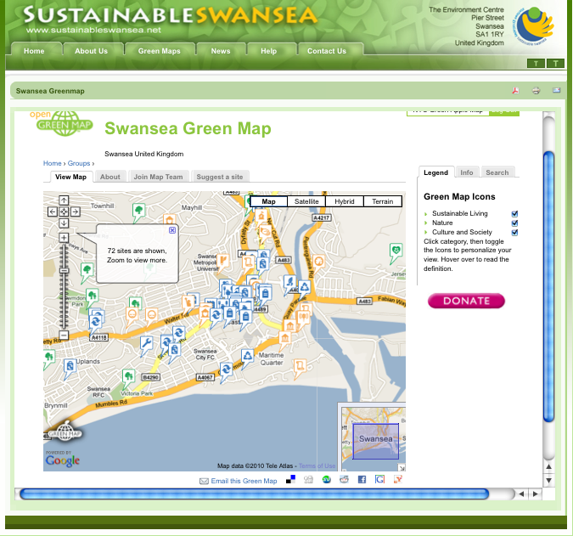

Option 2: Map-Only Layout

This specific customization option is available only to registered Mapmakers and requires a bit more work. If you would like to embed a map onto another website or blog, but without the toolbar and framing of the Open Green Map website, you must create an iframe widget first. The “Widget” tab is located on top of the map you want to share (you need to be logged in).

The Open Green Map platform allows for easy widget customization within your browser, including size, map type, and location. You can also change the default display of the basemap under the “Edit” tab. When finished with the desired settings, and you like how the widget looks, copy the HTML code from the “Widget HTML Code” field and paste it in your website or blog.

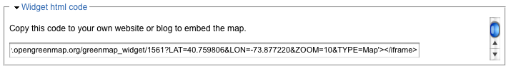

The pasted HTML should look something like this:

<iframe width='100%' height='500' frameborder='0' scrolling='no' marginheight='0' marginwidth='0' src='http://www.opengreenmap.org/greenmap_widget/1561?LAT=40.759806&LON=-73.877220&ZOOM=10&TYPE=Map'></iframe>

And the final result:

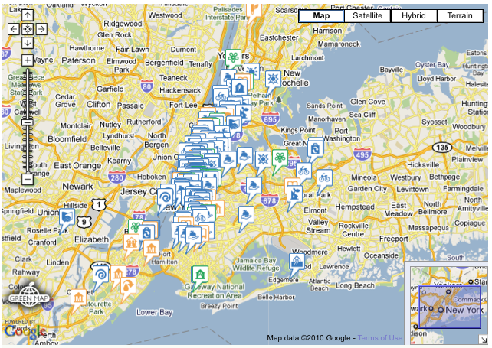

Here is how Baltimore's OGM looks, embedded in their own website: http://www.baltogreenmap.org/maps.shtml

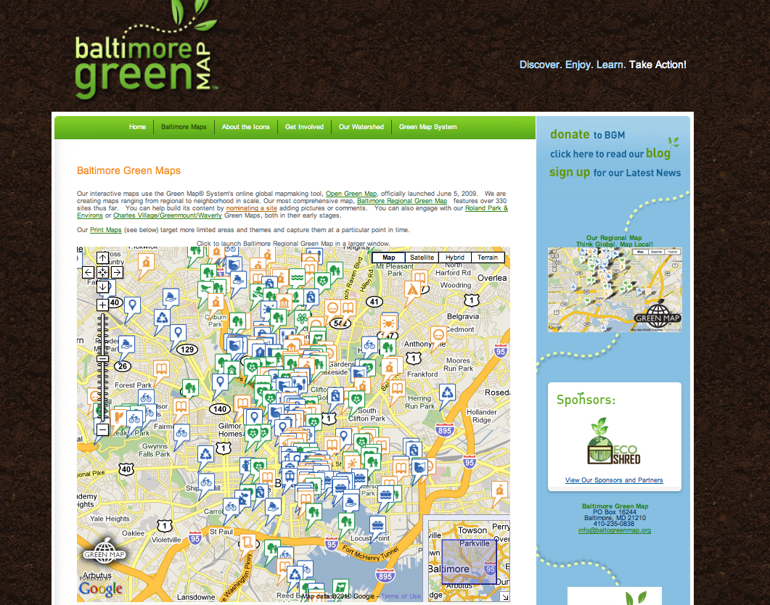

(if you check this online, notice the link above the map, which jumps to the OGM platform)

Option 3: Free-Style Layout

These iframe widgets can be altered in many ways by registered Mapmakers.

One useful edit creates a small iframe that can be placed in a blog's sidebar or within the text of a website. The code to do so is provided below, all you have to do is replace the source (in bold) with your own widget's HTML code, which can be found as described in Option 2, with the widget you created previously. “

<div id="map-home-outerdiv"><iframe scrolling="no" src="http://www.opengreenmap.org/greenmap_widget/1561?LAT=40.759806&LON=-73.877220&ZOOM=10&TYPE=Map” id="inneriframe"></iframe></div>

The final product:

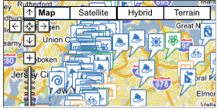

Feel free to edit and expand the code if you feel so inclined. All we ask is that the Green Map and Google logos should be visible within the window, meeting both parties' Terms and Conditions.

Option 4: Further Options!

If you want further layout options, experiment! Look at the Cape Town Green Map to see another example. http://www.capetowngreenmap.co.za/

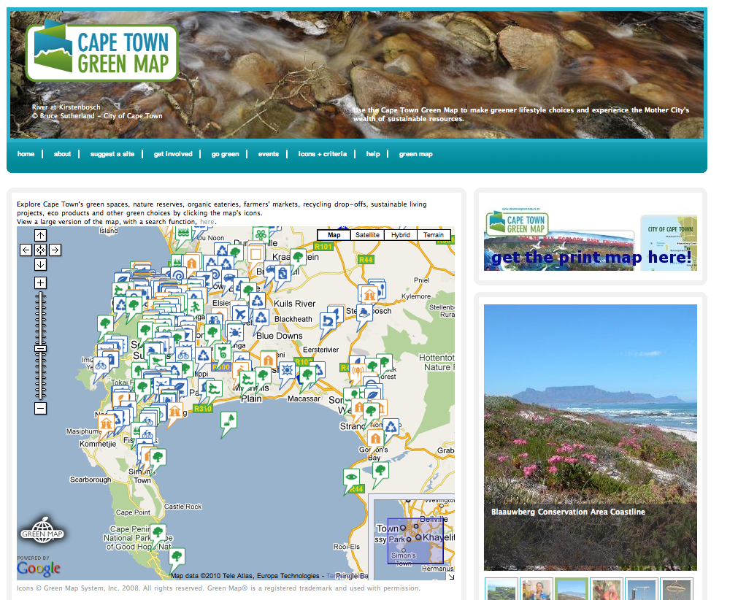

The Cape Town Green Map team used our iframe code (above in #3), but added an id of “innerframe” so its position can be offset using cascading style sheets (CSS). Here’s the code they used:

<div id="map-home-outerdiv"><iframe scrolling="no" src="http://www.opengreenmap.org/greenmap_widget/2701?LAT=-34.08&amp;LON=18.61&amp;ZOOM=10&amp;TYPE=Map" id="inneriframe"></iframe></div>

And here is the CSS they used :

#map-home-outerdiv {
height:485px;
overflow:hidden;
position:relative;
width:600px;
}

#map-home-outerdiv #inneriframe {
height:580px;
left:-5px;
position:absolute;
top:-5px;
width:605px;
}

Cape Town also offers users the option to click for a larger version above the iframe. Try it online and see how it works

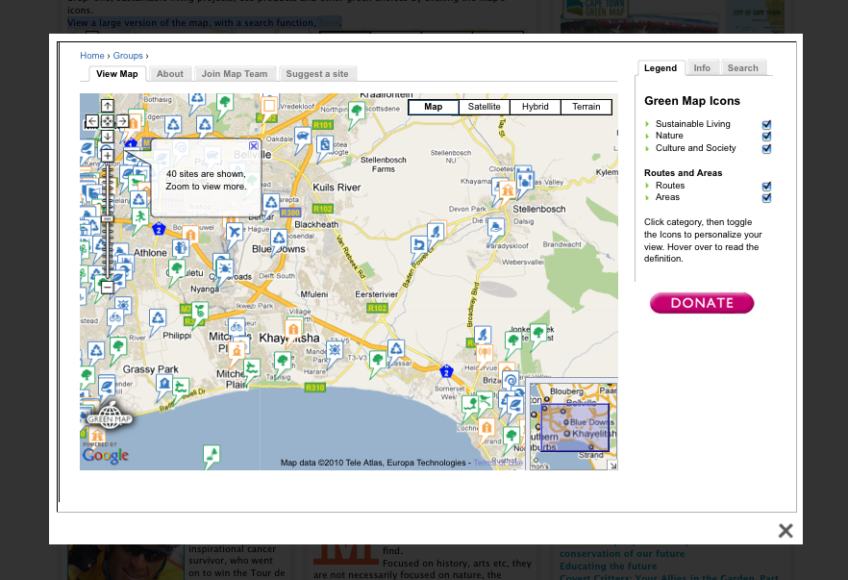

Impressive, right? The popup effect is a little more complicated.

The team used a Content Management System called Drupal, which is the same system we use on GreenMap.org and the Open Green Map platform. After installing the Lightbox2 module, they created a page containing the widget code:

<div id="outerdiv"><iframe scrolling="auto" src="http://www.opengreenmap.org/en/greenmap/cape-town-green-map" id="inneriframe"></iframe></div>

Here's the CSS they used:

#outerdiv {
height:550px;
overflow:hidden;
position:relative;
width:940px;
}

#outerdiv #inneriframe {
height:730px;
left:-35px;
position:absolute;
top:-144px;
width:1010px;
}

According to the developers, getting the “Green Map” menu item to work was difficult and had to be done outside of Drupal’s normal menu system. A Drupal expert modified the page.tpl.php template file to manually add the link, which can be seen below.

<?php if ($primary_links): ?>
<div id="primary">
<?php print theme('links', $primary_links); ?>
<div id="map-primary-menu"><a href="http://www.capetowngreenmap.co.za/node/84?format=simple" rel="lightframe[|width:960px; height:610px; scrolling: auto;]">green map</a></div>
</div> <!-- /#primary -->

We know it can become complicated, so do not hesitate to find professionals in your area who can help you. If you create anything interesting, please let us know! We’re always happy to see and help share new code with Green Mapmakers worldwide!

Special thanks to all the Green Mapmakers who created these great examples and to Glen Adams for sharing Cape Town's code. Thanks also to Andrew Carter, a New York volunteer, who created this i-frames tutorial.

March 2010

